“this” keyword in java->

There can be a lot of usage of **java this keyword**. In java, this is a **reference variable** that refers to the current object.

Use of this keyword->

*its used to refer current class instance variable.

“if we use the same name as a parameter and instance variable name so we got not right values so for correcting this

We have to use this key word”;

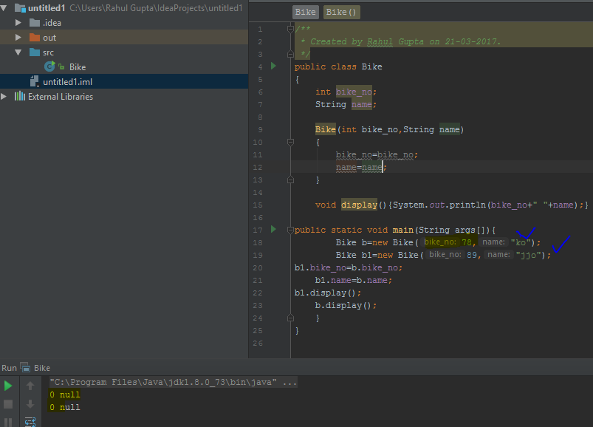

After solving the problem form this;

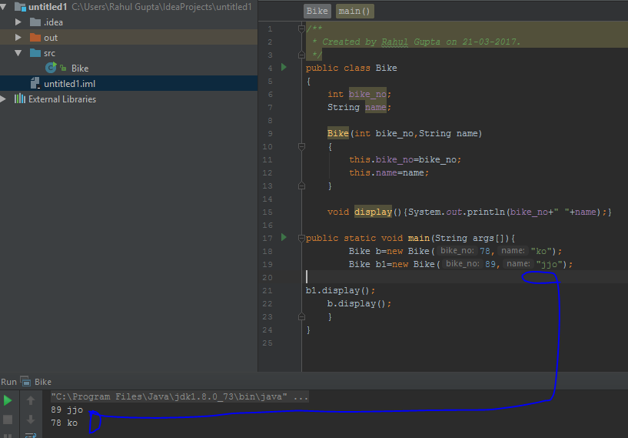

“if the parameter name are not same then there is no need for “this”

*to invoke current class method.

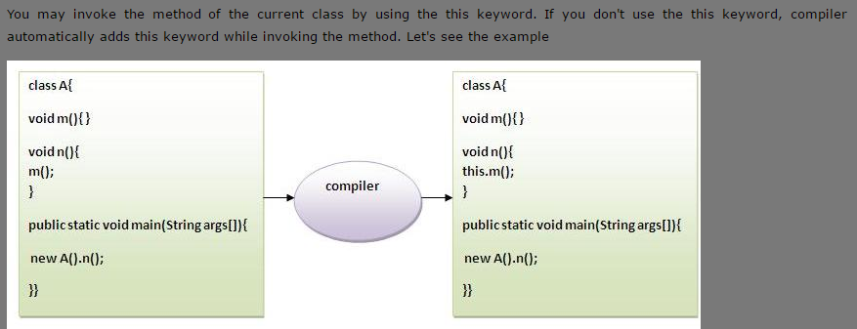

*this() can be used to invoke current class constructor.

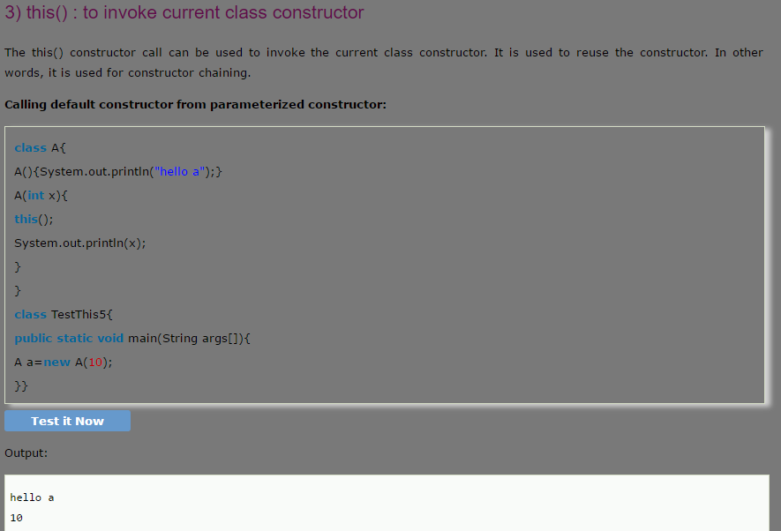

*this can be passed as an argument in the method call.

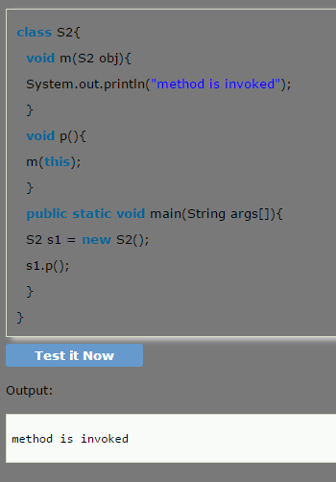

*this can be passed as argument in the constructor call.

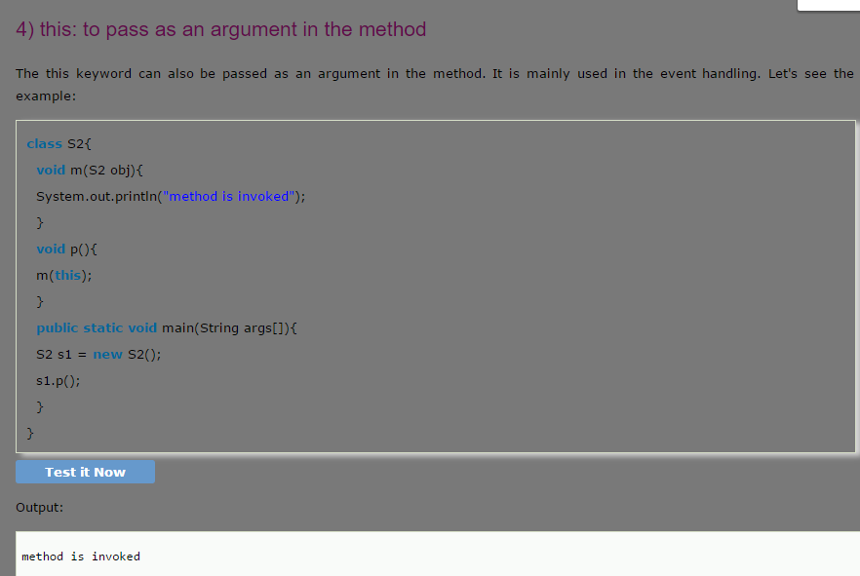

*this can be used to return the current class instance from the method.

1.in java->

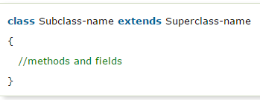

2. in c++->

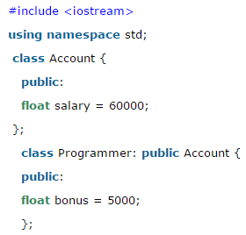

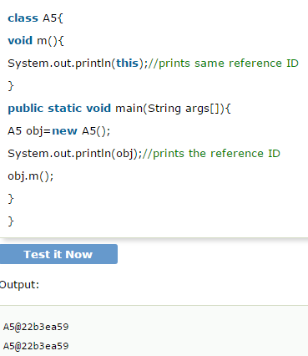

EXTEND KEYWORD->

* The **extends keyword** indicates that you are making a new class that derives from an existing class.

*The meaning of "extends" is to increase the functionality.

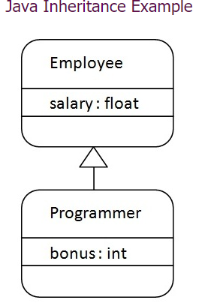

HERE PROGARMAR IS-A EMPLOYEE

Here programar is subclass and employee is super class.

First program of inheritance->1.child class

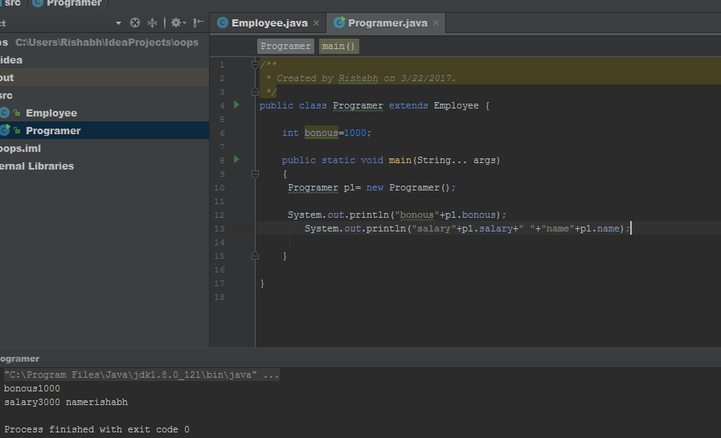

2.parent class->

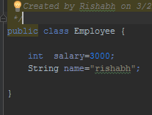

Types of inheritance in Java->

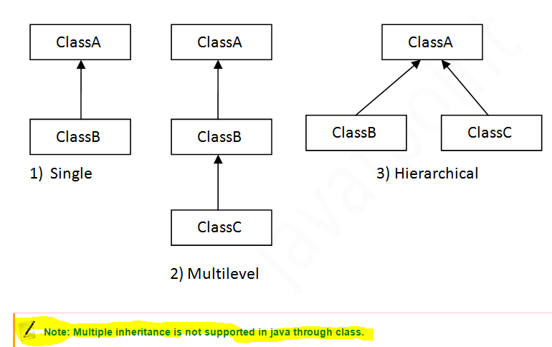

1.single inheritance->

As a example of

1.child class



2.parent class->



2.Multi-level Inheritance->

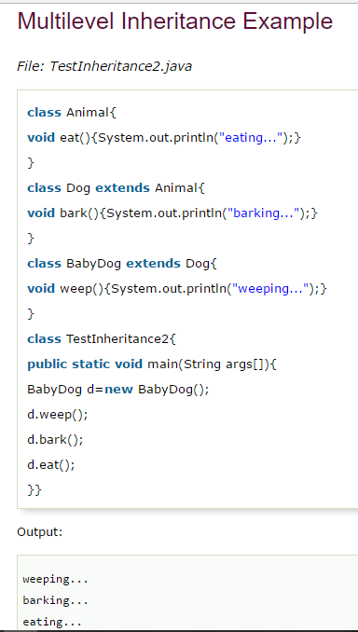

3. hierarchy->

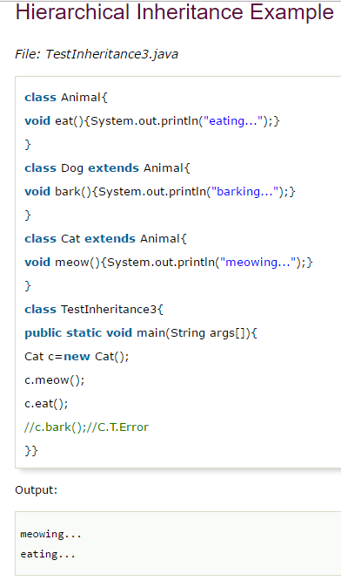

Q.why multiple inheritance not work in java->

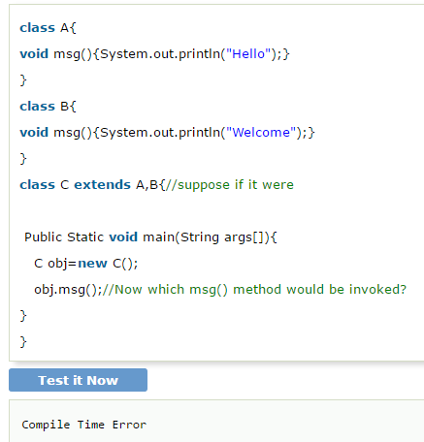

Aggregation in Java(HAS-A)->

*If a class contains the anothers class objetcs.

Example->

Employee object contains many informations such as id, name, emailId etc. It contains one more object named address, which contains its own informations such as city, state, country, zipcode etc. as given below.

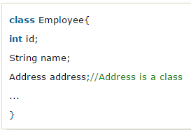

2.

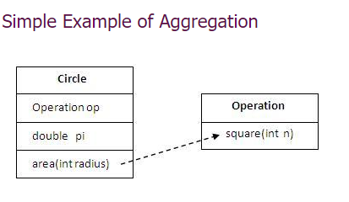

Implement->

